High Level Architecture Diagram of EAuction Application

Application Screenshots:
Application Cloud Url: https://d123wjml29q613.cloudfront.net/
Login Page

Registeration Page

Home Page Seller/Buyer

As a Seller you can ADD product

As a Seller you can delete the Product

As a seller you can not add BID

As a Buyer you can add/delete/update Bid

When Buyer perform the Delete Bid operation

Backend Postman ScreenShots:

User Registeration: https://d3g7rvebddzs5m.cloudfront.net/eAuction/signup
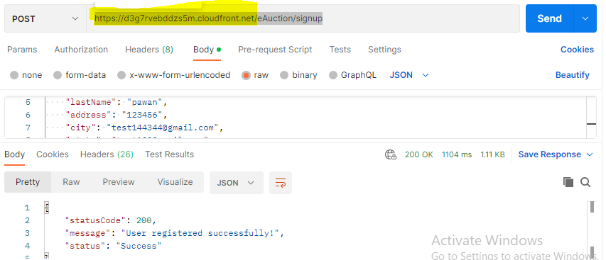

User Login:
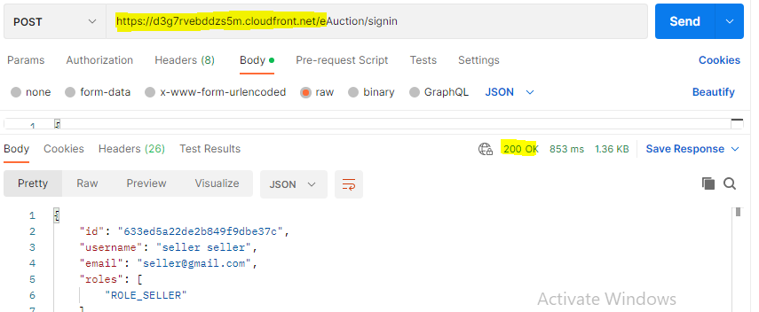

Add Produt By Seller
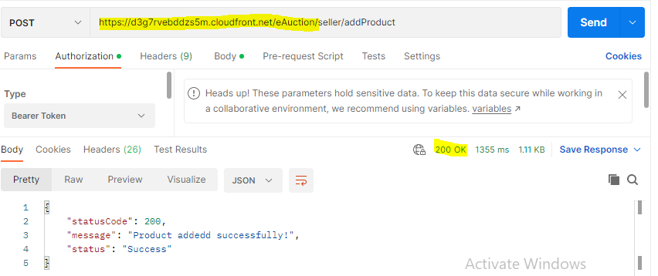

Add Bid by Buyer
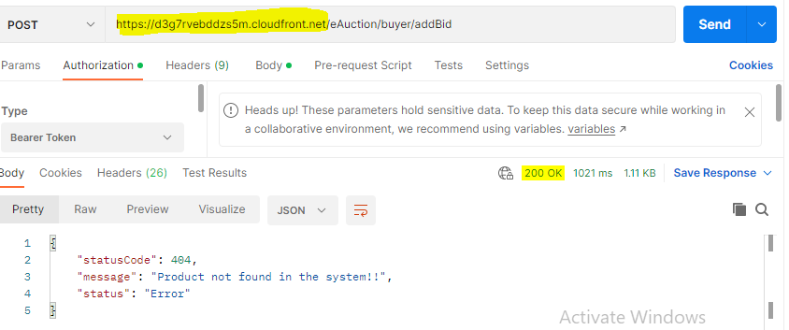

Database Collections:
